Vsat, Maritime, Broadcasting & Terrestrial Engineering

Company Overview

February2016

Khekonya Telecom Solutions Overview
Khekonya Telecom Solutions is a leading installer and Maintainer of Satellite Earth Stations, Maritime, broadcasting, terrestrial and ICT terminals in Africa and Middle East Countries. We provide locally based field engineers (FE) in those countries. Now we have more than 200 engineers, ready and available at short notice, with the in-depth expertise and experience to support your projects. We carry out work in Africa and Middle East countries on land and at sea, we go to jungles and mountainous regions, we visit deserts, towns and cities because our engineers are locally based in those countries they have the capability to visit almost anywhere.
Supporting client’s infrastructure in Africa and Middle East Countries can be a challenge to companies operating in Europe, USA and Asia etc. Companies often have customers operating in countries like Angola, Nigeria, Namibia, Gabon, Congo, Equatorial Guinea etc. can depend on Khekonya for fast response and quality support throughout the countries.

Our engineers are readily available to be mobilized to your customer’s site all over those countries for site surveys, civil & electrical work, installation & commissioning, maintenance or on call support within 24 hours. Khekonya has a team of qualified Engineers (Project Engineers, Network Engineers, ICT Engineers, Telecom Engineers, Maritime Vsat Engineers, Ground Vsat Engineers and Microwave Technicians with vast international experience with varies products. We deliver reliable installation and support services anywhere, anytime.
Our Manpower service is an extension of the managed Services providing point of contact for support, accountability, professionalism and service delivery. We have the flexibility to offer short or long term support services to any of our customers to support a variety of projects from Ground Vsat, Maritime Vsat, Fiber, Wimax, Microwave, Wi-Fi/hotspot, Lan/Wan, Networking, Security systems installation, warehousing/storage and on call support.
Khekonya Telecom Solutions Engineering Services
We offer engineering services on all V-sat/Maritime networks. Our team works seamlessly on 74cm small antennas to larger Earth Stations of up to 13M.
The team carry out work on various antennas from inclined orbit to Sea Tel. Last year we carried out on more than 1,000 installation/upgrades and 600 maintenance visits.

Our experience includes:
• Site Survey
• Civil & Electrical Work
• LAN & Security systems installation
• Installation & Commissioning i.e. Vsat, Fiber, Wimax & Wi-Fi
• On Call Support
• Corrective & Preventive Maintenance
• Networking, Warehousing and Storage Services.

Service Standards
We are a dynamic company that is setting the standards in our industry for others to follow. We have built an unparalleled reputation for quality service with more than 200 of our engineers having GVF Certified, Certified Wireless Network Engineering, Cisco Certified Network Associate and Certified Fiber Optic Specialist. We also have several engineers who are GVF certified instructors.
All our field engineers have a minimum of five years’ experience in Vsat, Maritime, Terrestrial installations and router configuration thus the team has an average of ten years’ experience. Khekonya instructors carry out visits to countries periodically to assess and train new engineers and also to upgrade skills of current engineers, this is ongoing to ensure standards of service.
Field Engineers customers visited
Our engineers visit a vast number of client sites in Africa. Below are just a small number of them:
• Vizocom, SAT-Africa, Bcomsat, Bentley walker, Cetel Satellite, Intelsat.
• DCS Telecom, Gilat Telecom, Ground Control, IPCOM, Measat, iSAT Africa, Commedian.
• Merlink, SAT-2K, SingTel, Space – Band, TS2-Space, Ultisat, Viasat, Xsat Global.
• Safaricom, Telkom Kenya, Vodacom. iWay Africa, Airtel, Jamii Telecom, MTN Kenya.

We also carry out works for numerous mining companies in Africa.

Africa Coverage
Countries where Khekonya provide services.
Kenya | Egypt | Somalia | Uganda | CAR
Algeria | Malawi | South Africa | Angola | Nigeria
Djibouti | Guinea | Cameroon | Guinea Bissau | Tunisia
Eritrea | Tanzania | South Sudan | Zambia | Madagascar
Chad | Namibia | Niger | Burundi | Gabon
Senegal | Togo | Burkina Faso | DR Congo | Sierra Leone
Ethiopia | Mali | Sudan | Botswana | Saudi Arabia
Benin | Congo | Gambia | Mauritania | Pakistan
Costa Rica | Ghana | Mozambique | Ivory Coast | Yemen
Morocco | Zimbabwe | Rwanda | Lebanon | Iraq

Technology Engineer’s Experience
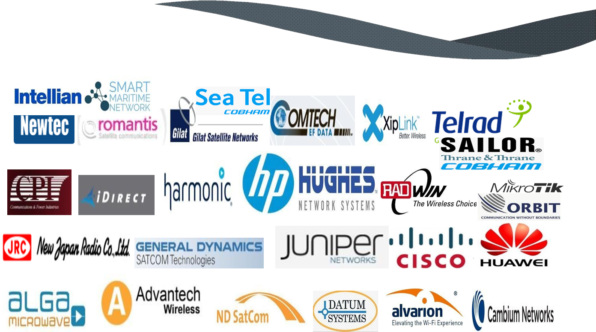

Khekonya Telecom Solutions Summary
Khekonya Telecom Solutions currently provides more than 250 local support engineers within Africa and Middle East countries, each with the in-depth expertise and experience to support your projects/jobs.
We can carry out site visits for maintenance and installations at short notice because we are already there in those countries. Our engineers have at least 5 years real field experience with most having more than 10 years’ experience. Whether you require a job done in Eritrea, Somalia, Pakistan or Iraq we are there for you in more than 45 countries.

Khekonya Telecom Solutions Guiding Principles and Core Values
Our commitment to Quality, Teamwork, Integrity, Professionalism and Safety guide our operations wherever we find ourselves.
Core Values.

• Safety
Nothing is so urgent that we cannot take time to do it safely.

• Quality
We will not compromise on the quality of our work and are always driving ourselves to optimize our performance through continuous analysis and improvement.

• Integrity
Our goal is to be the preferred and trusted service partner of choice for our stakeholders in Africa and to conduct business in an ethical and trustworthy manner. We say it as it is.

• Professionalism
Our clients trust us to consistently provide excellent service and we always act in a professional manner during the course of our operations.

• Teamwork
We value the power of collaboration and our employees have a responsibility to contribute equally and offer their unique perspective on a problem to arrive at the best possible solution.

